RideIt Driver Engagement & Performance Analysis

1. Project Overview
This project analyses RideIt's driver engagement, performance, and cancellation behavior using operational ride data. The objective is to identify the factors associated with better driver engagement and recommend business actions to improve retention, operational efficiency, and customer experience.

2. Dataset Summary
• Datasets: 2
• Data Size: 36972 rows
• Ride It Drivers Dataset: Driver profiles, ratings, gold level count, service type, country and marketing participation.
• RideIt Driver Activity Dataset: Offers, bookings, cancellations and completed rides.
• Missing Data:
- Driver Rating: 98 missing values
- Gold Level Count: 2,948 missing values

3. Data Cleaning & Preparation
• Removed 201 duplicate driver records caused by multi-service registrations.
• Replaced missing Driver Rating values using mean imputation.
• Replaced missing Gold Level Count values with 0.
• Standardized data types across both datasets.
• Created a one-to-many relationship using driver_id.
• 36,972 records analyzed

4. Business Analysis
1. Measure driver engagement using Acceptance Rate and Ride Completion Rate.
2. Identify factors associated with stronger engagement.
3. Compare performance across service types and countries.
4. Analyze cancellation behaviour and operational efficiency.
5. Evaluate the impact of marketing participation and loyalty programs.

5. Dashboard Development in Power BI
Developed five interactive dashboard pages:
• Home Page
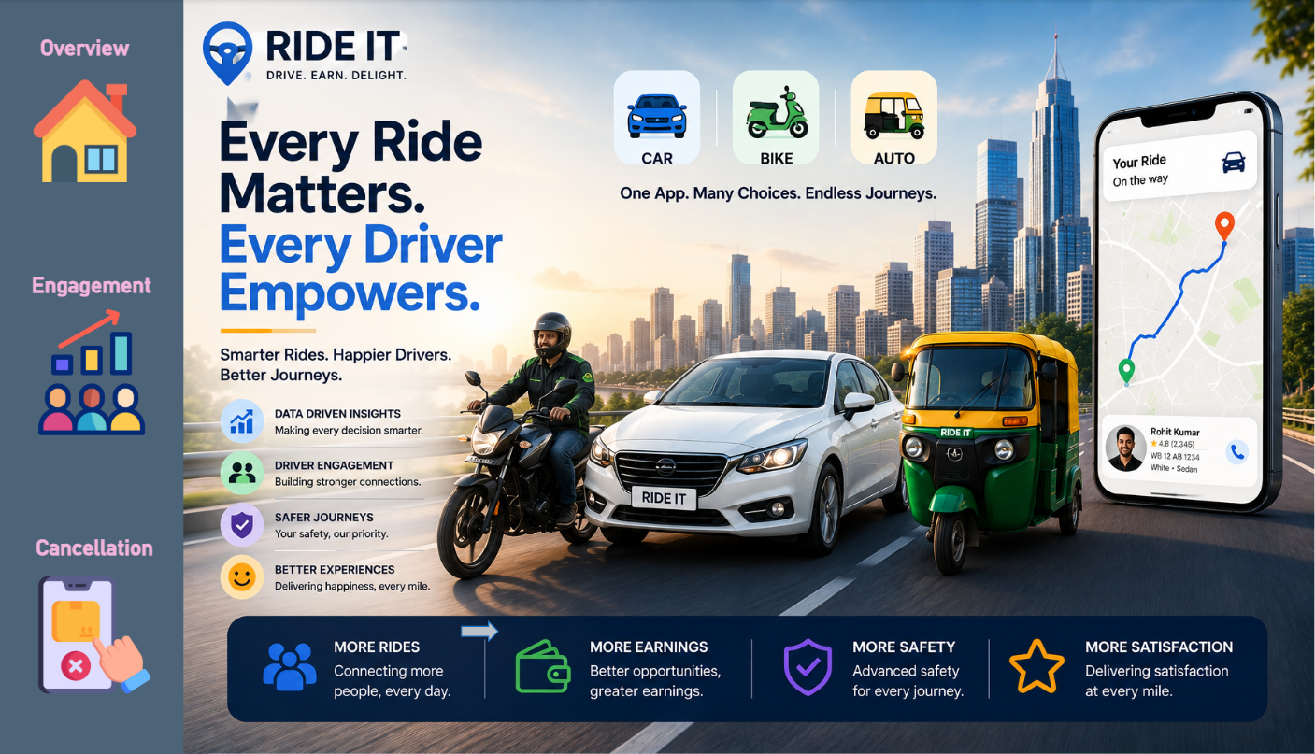
• Driver Engagement Overview
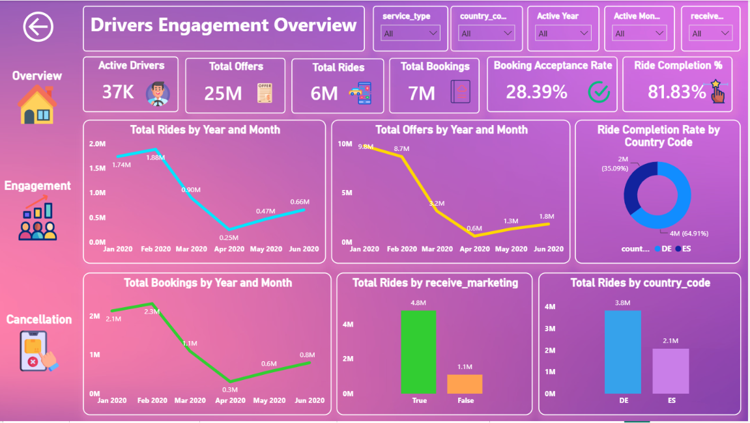
• Factors Influencing Engagement
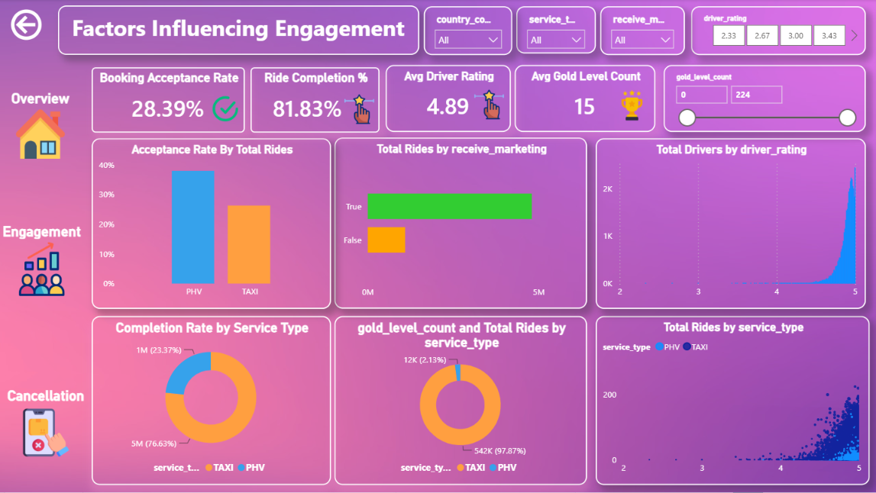
• Performance & Cancellation Analysis
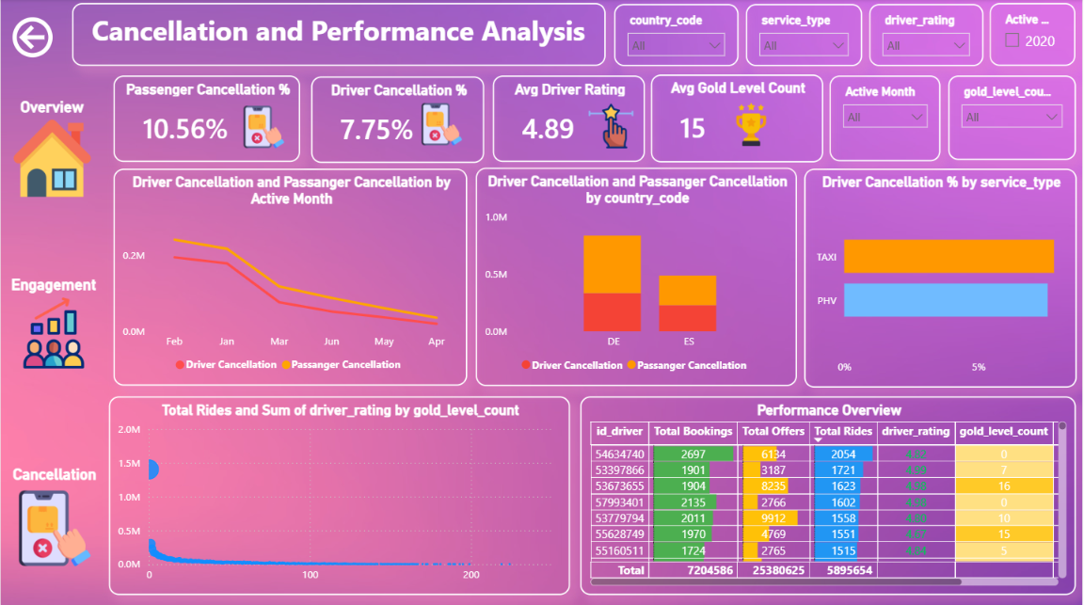
• Insights & Recommendations
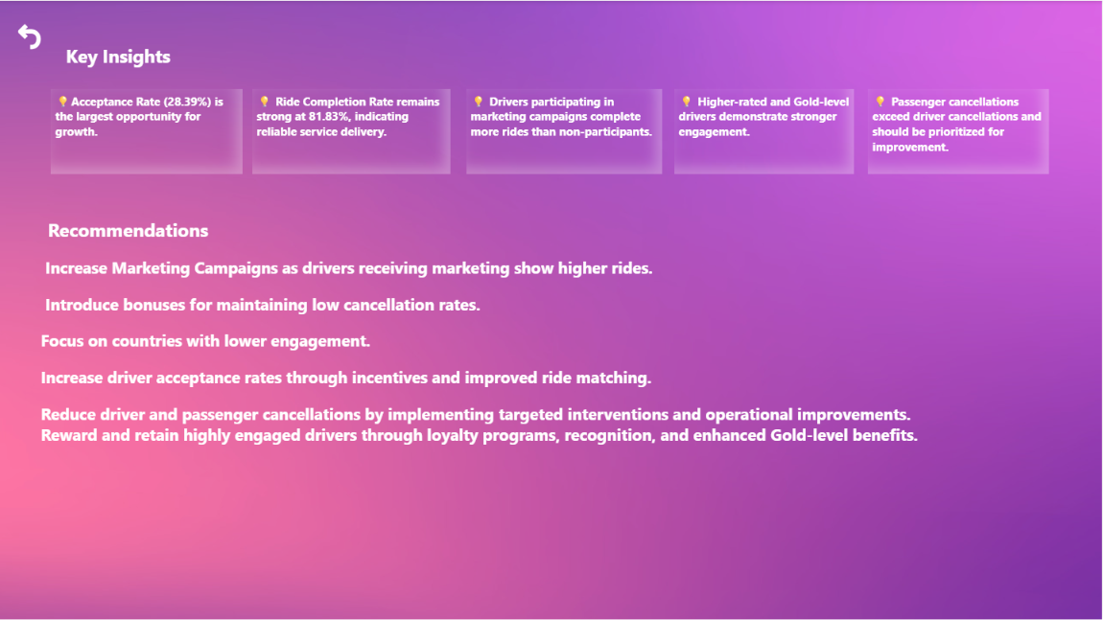

6. Key Insights
• Ride Completion Rate remained above 80%.
• Acceptance Rate remained around 28–30%.
• Highly rated drivers completed more rides.
• Drivers with higher Gold Level counts showed stronger engagement.
• Marketing participation positively influenced ride activity.
• Passenger cancellations exceeded driver cancellations.

7. Business Recommendations
• Increase acceptance rates through incentives.
• Reduce cancellations through alerts and matching improvements.
• Expand marketing campaigns to inactive drivers.
• Strengthen loyalty programs and Gold benefits.

8. Business Impact
Expected impact includes improved driver engagement, higher completion rates, lower cancellations, better customer experience, and increased driver retention.

9. Tools & Technologies
Power BI, Power Query, DAX, SQL, Excel.

10. Author
Mallayolla Vaishnavi
Aspiring Data Analyst | Power BI Developer | SQL | Power BI | Excel

